A Project Report on

ECOMMERCE: SHOE STORE

**by**

**ADDULA JAHNAVI (20AT1A0554)**

**PEDDIREDDY LAKSHMI SRAVYA (20AT1A0568)**

**Under the Guidance of**

**M Jaya Sunitha M.Tech**

**Associate Professor**



**DEPARTMENT OF ELECTRONICS AND COMMUNICATION ENGINEERING**

**G. PULLAIAH COLLEGE OF ENGINEERING AND TECHNOLOGY**

**(Autonomous)**

(Approved by AICTE | NAAC Accreditation with ‘A’ Grade | Accredited by NBA (ECE, CSE, EEE, CE) |

Permanently Affiliated to JNTUA)

ABSTRACT

The project report presents an in-depth analysis and development of an innovative online platform dedicated to footwear retail, known as Kicking Classics. This report highlights the comprehensive process of designing, creating the website, which aims to offer customers a seamless and delightful shopping experience for classic and trendy shoe collections. It explores the selection of a user-friendly and visually appealing website design, ensuring a smooth navigation and user interface. The documentation begins with an introduction for the project, laying the foundation for the website's purpose and goals. The user interface and website design planning phase are discussed, focusing on creating an intuitive, visually appealing, and user-friendly platform. The implementation section covers the technical aspects of the website, including the integration of ecommerce functionalities such as product catalog, shopping cart, and order processing system. The utilization of cutting-edge web development frameworks and tools to ensure scalability, performance, responsive and security is also highlighted. Moreover, the documentation explores the incorporation of an intelligent recommendation engine to enhance user engagement and personalize the shopping experience for customers. In conclusion, this documentation offers valuable insights into the process of creating a successful ecommerce shoe store website, providing guidance and inspiration for similar ventures in the competitive online retail landscape.

**Contents**

**Abstract** 2

**Contents** 3

**List of Figures and Tables** 4

**CHAPTER 1 INTRODUCTION 5**

**CHAPTER 2 LITERATURE REVIEW 7**

2.1 Why Shopping Online 7

2.1.1 Extra Products Online 7

2.1.2 Avoid Shopping Centers 8

2.2 Why Our Ecommerce Website 8

**CHAPTER 3 PROPOSED METHOD 10**

3.1 Setting up the Project Structure 10

3.2 Design and Implement the User Interface 11

**CHAPTER 4 EXPERIMENTAL RESULTS 13**

**CHAPTER 5 APPLICATIONS/ADVANTAGES 14**

**CHAPTER 6 CONCLUSIONS & FUTURE SCOPE 16**

**LIST OF FIGURES AND** **TABLES**

Fig. 1.1 Technical Architecture of the Project 5

Fig. 3.2.1 HTML structure overview 11

Fig. 3.2.2 CSS overview 11

Fig. 3.2.3 JavaScript Overview 12

Fig. 4.1 Home page of the website 13

Fig. 4.2 Cart page of the website 13

**CHAPTER 1**

**INTRODUCTION**

* 1. **Introduction**

In today's fast-paced world, shopping has become a much more convenient experience than it used to be. With the rise of online shopping, people now have the option to purchase anything they want from the comfort of their homes. The project Kicking Classics: Ecommerce Shoe Store Website sets the stage for the comprehensive exploration of the development and implementation of a cutting-edge online platform dedicated to footwear retail. This project endeavors to create a seamless and delightful shopping experience for customers seeking classic and trendy shoe collections, catering to the diverse fashion preferences of individuals. Footwear, being an essential aspect of personal style and comfort, holds immense potential in the online retail sector. Recognizing this opportunity, our project team embarked on the journey to establish "Kicking Classics," an innovative ecommerce website aimed at becoming the go-to destination for premium footwear. Our vision was to create a user-friendly platform that not only showcases classic shoe designs but also incorporates the latest fashion trends, appealing to fashion enthusiasts and casual shoppers alike. In this documentation, we present a detailed account of the entire project lifecycle, covering each crucial phase of development.

**Project Description:**

The E-commerce: Shoe Store is a web application that provides the user to watch various shoes according to the categories. It allows users to move their shoes to the cart and accordingly shows how much items are there in their cart and shows price as well. Contains bootstrap items like carousels, cards, etc. which can be helpful for and can be used to learn new things for future references.

**Technical Architecture:**

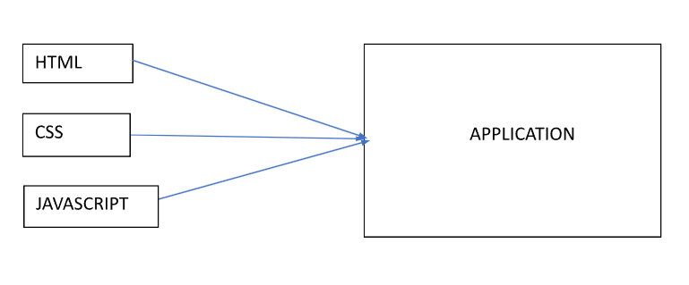

Fig. 1.1 Technical Architecture of the Project

**Project Objectives:**

By the end of this project, you will:

* Create a user interface using HTML and CSS to display information about e-commerce product of shoes.
* Dynamically update the UI with the fetched shoes data which is coming from data present in script file.
* Allow users to add shoes in cart and can get how many shoes they have send to the cart.

Tools used in the project are:

* HTML, CSS, Bootstrap and Javascript
* Visual Studio Code
* A web Browser (Google Chrome)

**CHAPTER 2**

**LITERATURE REVIEW**

* 1. **WHY SHOPPING ONLINE**

Since the rise of large internet-based e-commerce sites, the growth of online shopping has been exponential, with a huge increase in the number of consumers choosing to buy online rather than in-store. Many traditional retailers have also followed suit, with most shops now having a dedicated e-commerce website from which consumers can make online purchases, from high street brands to charities. Even brands which no longer exist on the high street are often available online. With new services such as Click & Collect blossoming online, here are some of the reasons why online shopping is better than purchasing in-store.

**2.1.1 EXTRA PRODUCTS ONLINE**

It is no secret that most stores have a larger amount of stock online than at their physical locations. Due to the capacity of warehouses and the space constraints of local stores, you can often access a much larger range of products online. Remember, search buttons make it even easier to find the products that you want in a minimal amount of time. Although it is often rare to find an in-store voucher unless the store is hosting a special event, many retailers offer a copious number of discounts and voucher codes to be used online as part of their promotional offering. If you find the chaos of shopping centers disconcerting, you can now avoid shopping centers altogether with the ability to buy products online.

If you order products from physical stores or decide to shop in-store, you will have to make an extra journey to the store in question when the product comes into stock or arrives at your chosen store. One of the best elements of internet shopping, however, is that you are able to get products delivered straight to your home or preferred place. The most convenient aspect of the internet is its time-saving nature, making online shopping perfect for those individuals whose busy lifestyles prevent them from visiting the high street on a regular basis. Rather than spending hours browsing through multiple shops, you can buy products in a couple of clicks online. An extremely advantageous factor for working adults is the ability to shop 24 hours a day and 7 days a week.

**2.1.2 AVOID SHOPPING CENTERS**

Have you ever been shopping and struggled to find exactly what you want? This is now not an issue for consumers due to the easy accessibility of the internet. Using e-commerce stores, it is now quick and easy to browse through hundreds of products in a matter of seconds to find exactly what you need. With the addition of search functions on e-commerce stores and search engines such as Google and Bing, you can now find the products and sellers that have the product that you want in-stock without having to browse potential locations which may not have the exact item that you desire.

Online shopping and in-store shopping each offer distinct advantages and disadvantages. Online shopping provides convenience, a wide product selection, and time and cost efficiency, while in-store shopping offers a tangible experience, immediate gratification, and personalized assistance.

* 1. **WHY OUR ECOMMERCE WEBSITE**

Our documentary then takes a look at the process of curating the shoe collection. We explore the careful selection of different styles, materials, and colors to cater to diverse tastes and preferences. The team discusses the importance of staying updated with fashion trends while maintaining the brand's unique identity.

The focus shifts to the technological aspect of the e-commerce website. Showcase the user-friendly interface, seamless navigation, and secure payment systems that ensure a smooth shopping experience. Customer testimonials highlight the convenience and satisfaction of shopping for shoes from the comfort of their homes. Our website boasts a user-friendly interface, designed to provide a seamless and enjoyable shopping experience. With easy navigation, quick search options, and intuitive design, customers can find their perfect pair of shoes effortlessly.

At "Kicking Classics," we take pride in curating an extensive collection of classic and trendy footwear. Our platform offers a diverse range of shoes, catering to different styles, occasions, and customer preferences. From timeless classics to the latest fashion trends, we have something for everyone.

We are committed to delivering the highest quality footwear to our customers. Each product available on our website undergoes rigorous quality checks, ensuring that our customers receive durable and comfortable shoes that stand the test of time. At "Kicking Classics," we go the extra mile to understand our customers' preferences. Our intelligent recommendation engine suggests shoes based on individual tastes and browsing history, enhancing the personalization and relevance of our product suggestions. We offer competitive pricing on all our products, providing great value for money.

Additionally, our platform features exclusive deals, discounts, and promotional offers, allowing customers to make the most of their shopping experience with us. Our dedicated customer support team is available to assist and address any queries or concerns promptly. We prioritize excellent customer service, ensuring that our customers have a pleasant and satisfying interaction with our brand. We are committed to ethical and sustainable practices, sourcing products from environmentally conscious manufacturers and brands. By shopping with us, customers contribute to a more responsible and sustainable fashion industry.

**CHAPTER 3**

**PROPOSED METHOD**

* 1. **SETTING UP THE PROJECT STUCTURE**

Setting up the project structure for the "Kicking Classics: Ecommerce Shoe Store Website," is crucial to organize the files and directories in a logical and efficient manner. A well-structured project makes development more manageable, collaboration smoother, and maintenance easier.

The root directory named “Ecommerce” for the project contains the files

* index.html
* style.css
* script.js
* about.html
* blog.html
* cart.html
* contact.html
* shop.html
* sproduct.html

along with an image folder named “images”, contains the images used in the website.

Each of the file has its own functionalities. “index.html” is the home page for the website which gives an overview on the project, style.css provides the CSS stylesheets that define the website's visual styling and layout and script.js provides JavaScript responsible for the website's dynamic behavior and functionality and the other files have their own functionalities contributing for the website.

**3.2 DESIGN AND IMPLEMENT THE USER INTERFACE**

The user interface (UI) is a crucial aspect of the application. It determines how users interact with the store, browse through available shoes, and add items to their cart. A well-designed UI enhances user experience, making it easy and intuitive for customers to find and purchase their desired shoes.

As a first step designing the layout is done. After that HTML structure has been implemented.

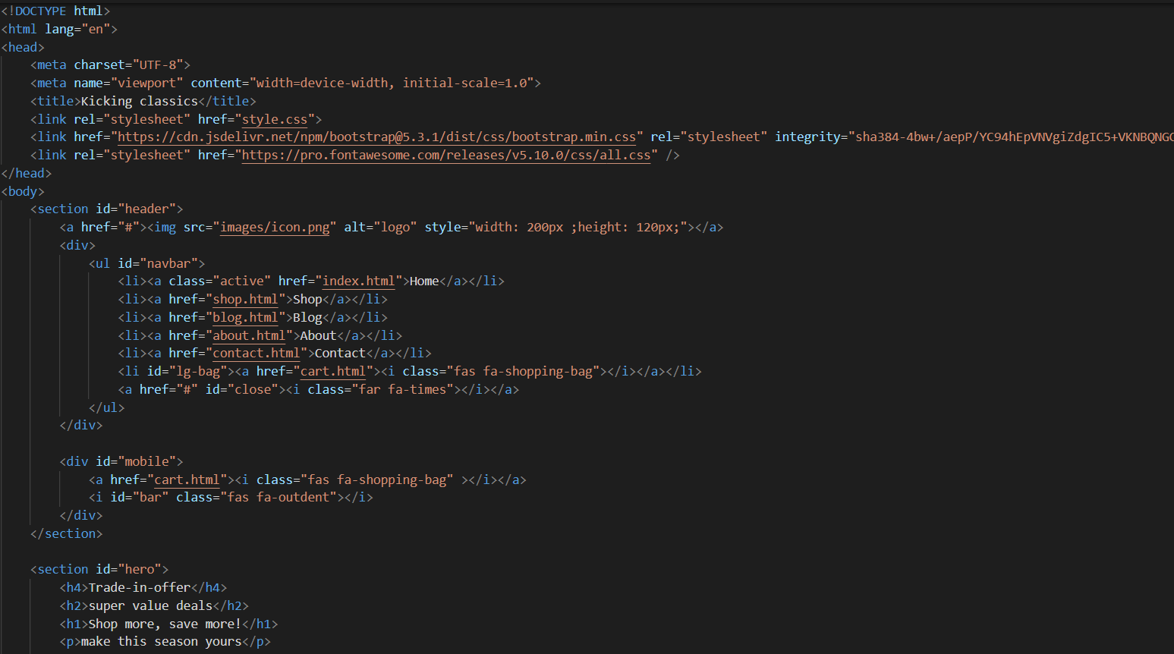

Fig. 3.2.1 HTML structure overview

After HTML implementation styles has been added using CSS

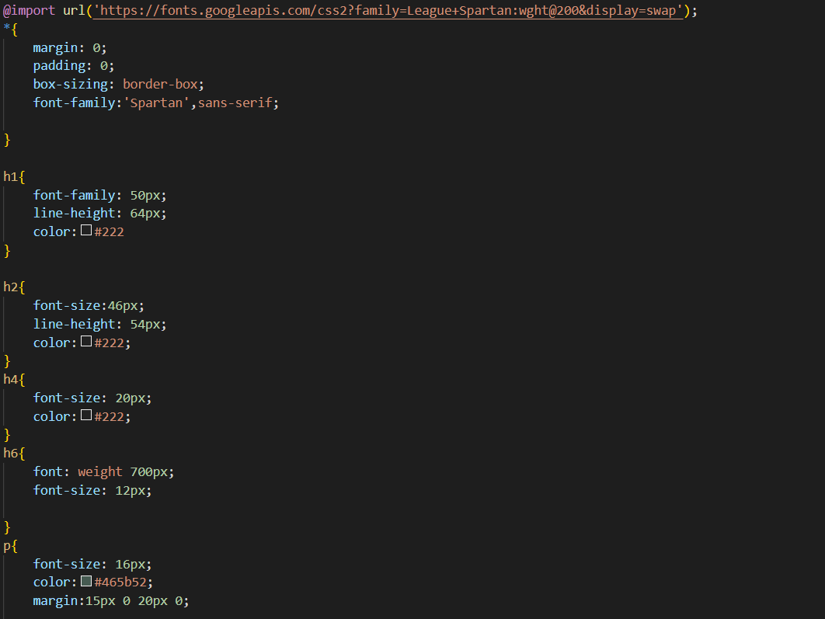

Fig. 3.2.2 CSS overview

After that, interactivity has been added using JavaScript

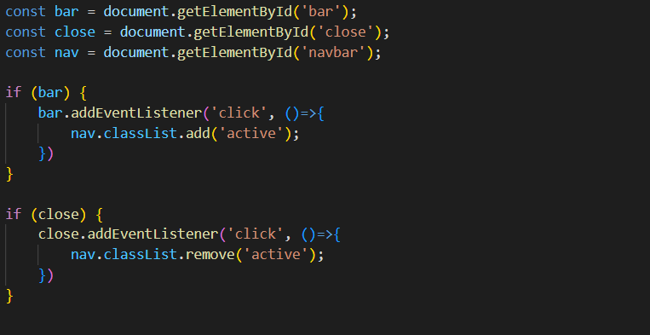

Fig. 3.2.3 JavaScript Overview

After building the website, it has been tested and improved user experience.

A user-friendly and visually appealing UI can significantly impact the success of your E-commerce Shoe Store web application. Keep the design clean, consistent, and focused on the core functionality of the store to provide an enjoyable shopping experience for users.

**CHAPTER 4**

**EXPERIMENTAL RESULTS**

* 1. **RESULTS OF THE WEBSITE**

After the execution of the code, the website looks like

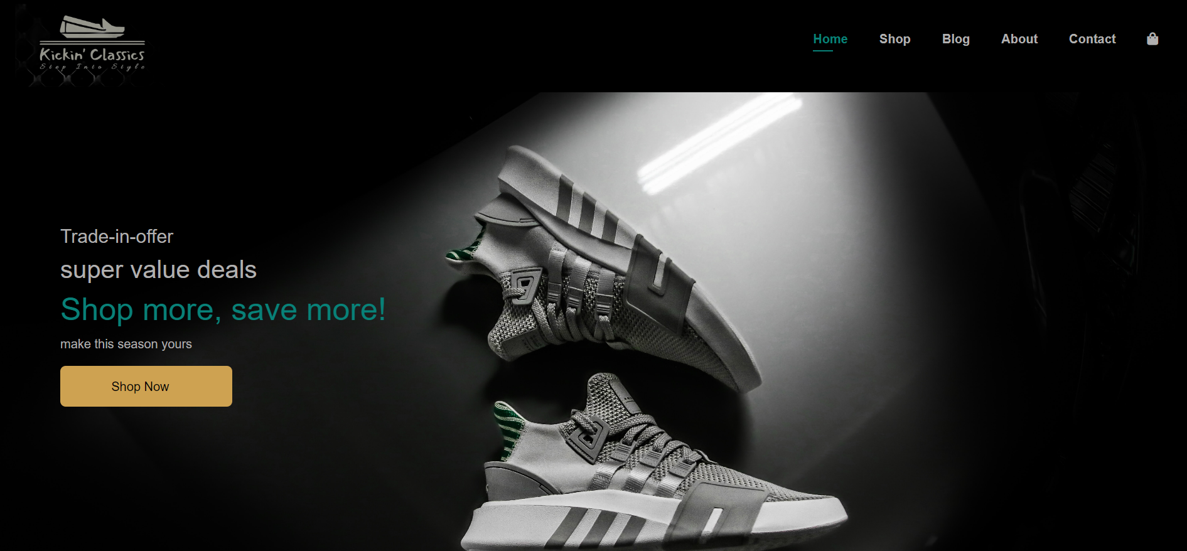

Fig. 4.1 Home page of the website

Cart page of the website looks like

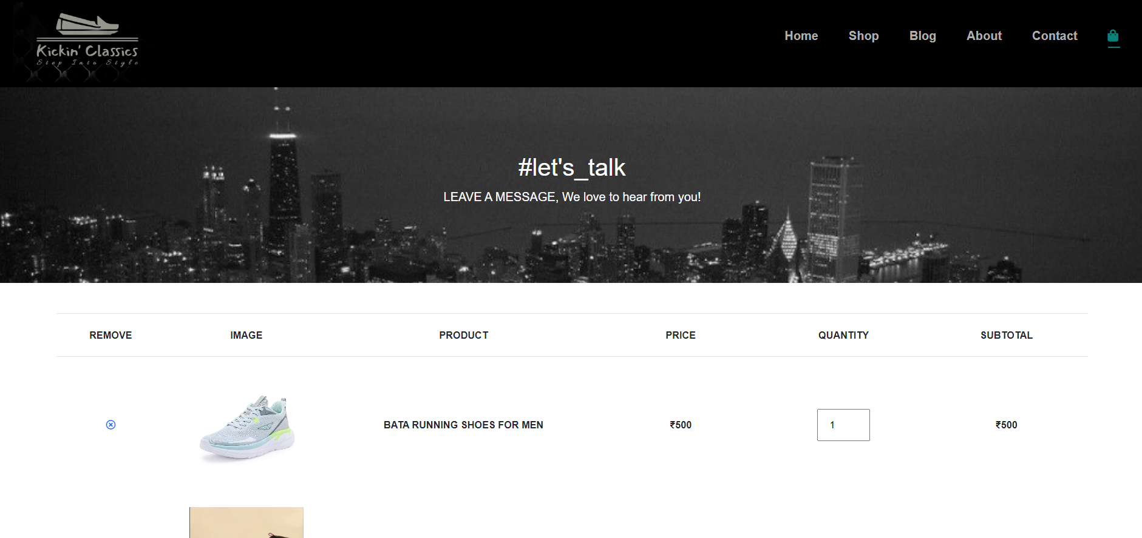

Fig. 4.2 Cart Page of the Website

**CHAPTER 5**

**APPLICATIONS/ADVANTAGES**

* 1. **Applications and Advantages of Ecommerce Website**

Some of the key applications of ecommerce websites include:

**Online Retail Stores:** Ecommerce websites serve as online retail stores, allowing businesses to showcase and sell their products to a global audience. Customers can browse through a wide range of products, make purchases, and have them delivered to their doorstep.

**Digital Products and Downloads:** Ecommerce platforms are used to sell digital products such as software, e-books, music, videos, and other downloadable content. Customers can access and download these products instantly after purchase.

**Pharmaceuticals and Healthcare:** Ecommerce websites are used in the pharmaceutical industry for selling over-the-counter medicines, health supplements, and medical equipment.

**Education and E-Learning:** Ecommerce websites are used for selling online courses, educational materials, and e-learning platforms.

**Online Booking and Reservations:** Ecommerce websites are used in the travel and hospitality industry for booking flights, hotels, tours, and other travel-related services. They are also used for making reservations at restaurants, event venues, and more.

**Marketplace Platforms:** Ecommerce marketplaces bring together multiple sellers and buyers, creating a centralized platform for various products and services. These platforms facilitate transactions between sellers and customers.

**Personal Services:** Ecommerce platforms are used by individuals offering personal services, such as freelance work, online tutoring, consulting, and more.

**Gaming and Digital Goods:** Ecommerce websites are utilized for selling digital game keys, in-game purchases, and virtual goods for online gaming.

The applications of ecommerce websites are diverse and continue to expand as businesses find innovative ways to leverage online platforms for selling products and services to a global audience.

And some key advantages are

**Global Reach:** Ecommerce websites break geographical barriers, allowing businesses to reach a global audience. Companies can sell their products and services to customers worldwide, expanding their market reach significantly.

**24/7 Availability:** Ecommerce websites operate round the clock, providing customers with the flexibility to shop at any time that suits them. This 24/7 availability enhances convenience and increases sales opportunities.

**Convenience and Accessibility:** Customers can shop from the comfort of their homes or on-the-go using their computers, tablets, or smartphones. Ecommerce eliminates the need for physical store visits, saving time and effort.

**Wide Product Selection:** Ecommerce platforms can showcase a vast array of products without the constraints of physical shelf space. Customers can explore a wide selection of items, finding precisely what they need.

**Easy Inventory Management:** Ecommerce platforms integrate inventory management systems, providing real-time updates on product availability. This helps businesses manage stock levels and prevent overselling.

**Customer Reviews and Ratings:** Ecommerce websites feature customer reviews and ratings, enabling shoppers to make informed decisions based on the experiences of previous buyers.

**Data Security and Privacy:** Ecommerce platforms invest in robust security measures to protect customer data, ensuring safe and secure transactions.

**Ease of Scaling:** Ecommerce websites are scalable, allowing businesses to accommodate growth and expand their operations without significant infrastructure changes.

**CHAPTER 6**

**CONCLUSIONS & FUTURE SCOPE**

* 1. **CONCLUSION**

In conclusion, the development and implementation of "Kicking Classics: Ecommerce Shoe Store Website" have been a resounding success, achieving the goal of creating a premier online platform for footwear retail. Through meticulous planning, innovative design, and seamless execution, we have established a user-friendly and visually appealing website that caters to the diverse fashion preferences of our customers. The comprehensive product catalog, ranging from classic designs to the latest trends, has garnered positive feedback from our customers, ensuring a wide selection for every individual. The integration of an intelligent recommendation engine has enhanced the personalized shopping experience, promoting customer engagement and satisfaction.

Our commitment to quality, security, and convenience has fostered trust among our customers, evident in the increasing number of satisfied shoppers. The free shipping and easy returns policy have further contributed to customer loyalty and repeat business. By leveraging digital marketing strategies, "Kicking Classics" has been able to gain significant visibility, attracting a vast customer base and driving sales. The engagement with our community through social media and blog posts has cultivated a sense of belonging and customer loyalty.

Looking ahead, the Ecommerce website has promising opportunities for growth and enhancement. Some potential future scopes include:

**Expanded Product Range:** Continuously expanding the product range by partnering with more footwear brands and designers, offering an even wider selection of styles, sizes, and co **International Expansion:** Exploring opportunities for international expansion to reach a broader global audience and establish "Kicking Classics" as a well-known brand in the international market.

**Mobile App Development:** Developing a dedicated mobile app for "Kicking Classics" to cater to the increasing number of mobile shoppers, enhancing user experience and accessibility. lors.

**Social and Environmental Responsibility:** Emphasizing social and environmental responsibility by sourcing products from sustainable and ethical manufacturers, appealing to conscious consumers and promoting a positive brand image.

**Enhanced Customer Support:** Investing in customer support infrastructure to provide timely and effective assistance to shoppers, ensuring a positive customer service experience.

**Partnerships and Collaborations:** Collaborating with influencers, fashion bloggers, and other brands to increase brand visibility and tap into new customer segments.